

Introduction to Computing (ITC)

Spring 2021: Assignment 2

**INSTRUCTIONS:**

**Deadline Date:** **­­­­­­­­­­­­­3rd May, 2021 till 5 pm (SOFT COPY)**

* **This is an individual Assignment.**
* **Viva/Quiz may be conducted for evaluation in next class**
* **SUBMIT SOFT SOLUTION ON CMS Portal (LATE PENALTY 25% PER DAY)**
* **ATTACH THIS TITLE PAGE AFTER FILLING TO YOUR ASSIGNMENT (5 MARKS)**
* **SUBMIT .cpp FILE ON CMS PORTAL FOR ALL QUESTIONS.**
* **DRAW FLOW CHART FOR EACH QUESTION ON PAPER AND ATTACH CLEAR PICTURES OF FLOW CHART ON WORD DOCUMENT.**
* **ATTACH ZIP FILE TO PORTAL CONTAINING FLOW CHART WORD DOCUMENT AND .cpp FILE.**

**FOR ONLINE SUBMISSION NAMING CONVENTION: (5 MARKS)**

\***FILES WITH WRONG NAME OR EXTENSION WILL BE DELETED** Use the following pattern for naming the file

(A2SectionNameFourDigitRollNumberFirstName.docx) e.g. A2M20346Haris.docx

**Total Marks= 40 (30+10 for front page)**

**Question no. 1: (5+5)**

1. **Write C++ Program for following flow chart. (5)**

|  |
| --- |
|  |

|  |
| --- |
| //Copy-paste your code here  #include <iostream>  using namespace std;  int main()  {      float height, weight, bmi;      cout << "Enter weight in kg : ";      cin >> height;      cout << "height in meters : ";      cin >> weight;      bmi = weight / (height * height);     if(bmi>=0 && bmi <=18.5){         cout << "Underweight"<<endl;     }     else if(bmi>=18.5 && bmi <=24.9){         cout << "Normal"<<endl;     }     else if(bmi>=25 && bmi <=29.9){         cout << "Overweight"<<endl;     }     else          cout << "Obese";      return 0;  } |

Question no 1

b

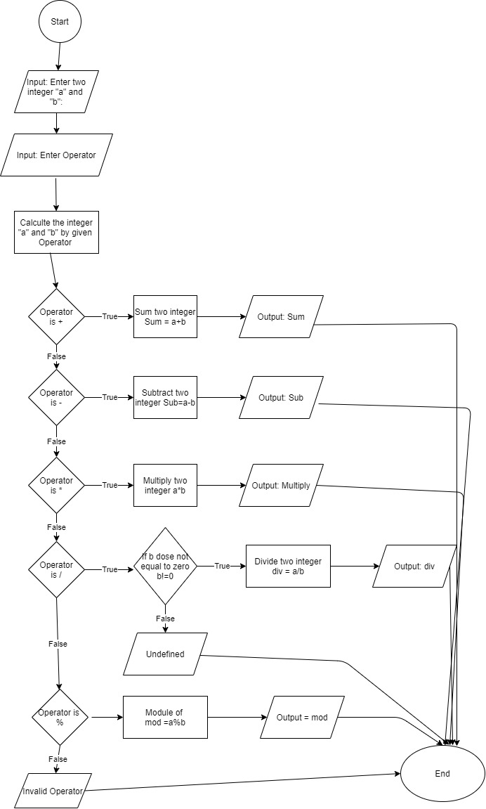

Question no 2

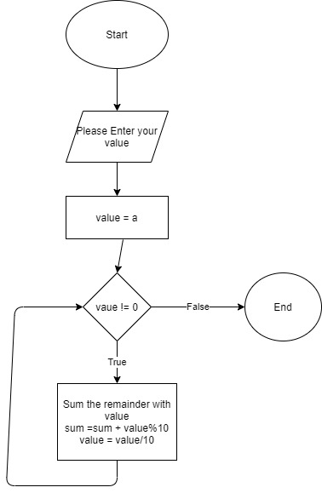

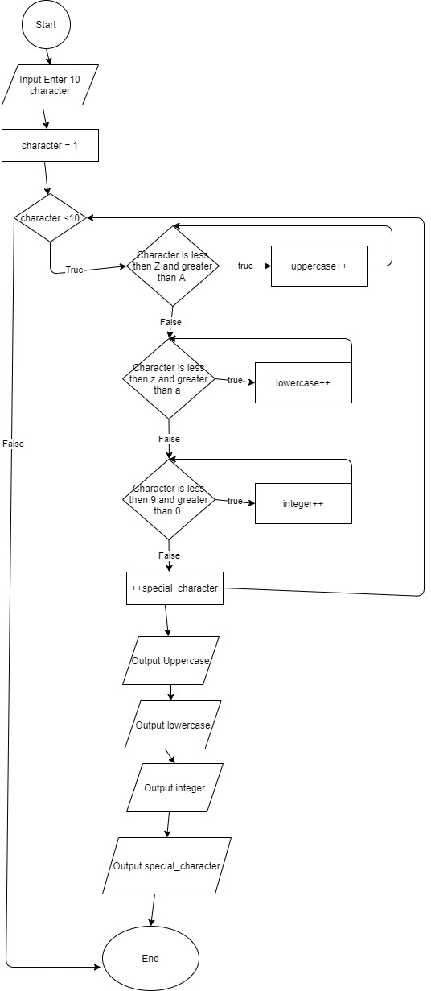  
Question no 3